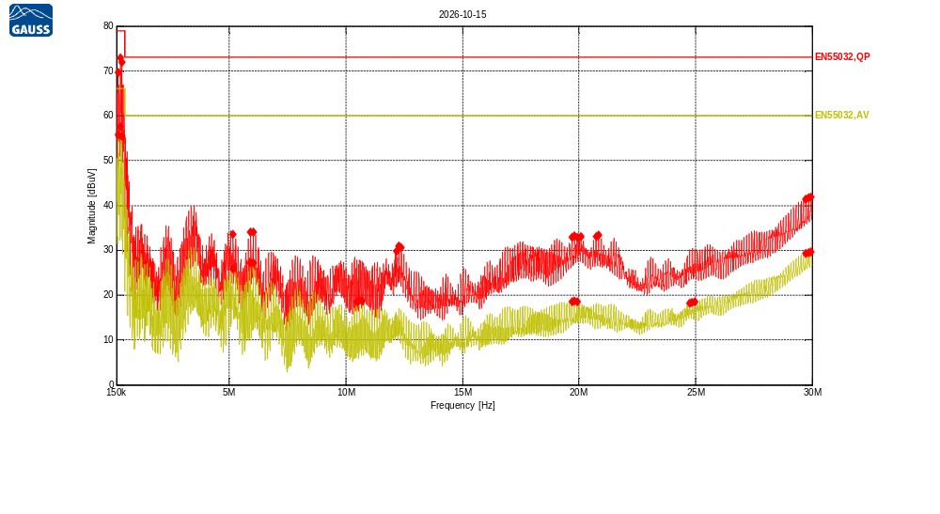
Receiver Model:
Protocol Number:
Serial Number:
Operation State:
Notes:
123123

Traces:
Trace | Start | Step | Stop | IF Bandwidth | Detector | Dwell time | Attenuation | Transducer | LISN | Notes
Scan2 | 150.0 kHz | 5.0 kHz | 30.0 MHz | 9kHz | QP | 200.0 ms | Auto | TDF1 | -
Scan1 | 150.0 kHz | 5.0 kHz | 30.0 MHz | 9kHz | Average | 200.0 ms | Auto | TDF1 | -

Transducers:
TDF1: LISN Compower AC Line

Limit lines:
EN55032,QP: EN55032 Cond,Class A,QP, 150kHz-30MHz
EN55032,AV: EN55032 Cond,Class A,Average, 150kHz-30MHz
Scan2: 150.0 kHz, 5.0 kHz, 30.0 MHz; IF:9kHz, 200.0 ms QP, Att AutodB
f | Mag [dBuV] | Limit | Diff | Trans | Name | Comment
218.66125 kHz | 69.59 | 79.00 | 9.41 | 0.18 | EN55032,QP
323.941834 kHz | 72.97 | 79.00 | 6.03 | 0.06 | EN55032,QP
378.870834 kHz | 71.98 | 79.00 | 7.02 | 0.04 | EN55032,QP
5.15311643 MHz | 33.56 | 73.00 | 39.44 | 0.08 | EN55032,QP
5.91754502 MHz | 34.01 | 73.00 | 38.99 | 0.08 | EN55032,QP
6.0228256 MHz | 34.12 | 73.00 | 38.88 | 0.08 | EN55032,QP
12.1611414 MHz | 29.84 | 73.00 | 43.16 | 0.08 | EN55032,QP
12.2664219 MHz | 30.88 | 73.00 | 42.12 | 0.08 | EN55032,QP
12.3762799 MHz | 30.69 | 73.00 | 42.31 | 0.08 | EN55032,QP
19.7047241 MHz | 32.83 | 73.00 | 40.17 | 0.02 | EN55032,QP
19.8145821 MHz | 33.17 | 73.00 | 39.83 | 0.02 | EN55032,QP
19.9152852 MHz | 32.98 | 73.00 | 40.02 | 0.02 | EN55032,QP
20.0846496 MHz | 33.07 | 73.00 | 39.93 | 0.02 | EN55032,QP
20.7346428 MHz | 33.12 | 73.00 | 39.88 | 0.02 | EN55032,QP
20.8445008 MHz | 33.32 | 73.00 | 39.68 | 0.03 | EN55032,QP
29.7475762 MHz | 41.40 | 73.00 | 31.60 | 0.23 | EN55032,QP
29.8574342 MHz | 41.71 | 73.00 | 31.29 | 0.24 | EN55032,QP
29.9627148 MHz | 41.89 | 73.00 | 31.11 | 0.24 | EN55032,QP

Scan1: 150.0 kHz, 5.0 kHz, 30.0 MHz; IF:9kHz, 200.0 ms Average, Att AutodB
f | Mag [dBuV] | Limit | Diff | Trans | Name | Comment
214.083834 kHz | 55.68 | 66.00 | 10.32 | 0.19 | EN55032,AV
323.941834 kHz | 57.50 | 66.00 | 8.50 | 0.06 | EN55032,AV
378.870834 kHz | 55.37 | 66.00 | 10.63 | 0.04 | EN55032,AV
5.15311643 MHz | 25.84 | 60.00 | 34.16 | 0.08 | EN55032,AV
5.9129676 MHz | 27.16 | 60.00 | 32.84 | 0.08 | EN55032,AV
6.0228256 MHz | 27.13 | 60.00 | 32.87 | 0.08 | EN55032,AV
10.4720746 MHz | 18.51 | 60.00 | 41.49 | 0.09 | EN55032,AV
10.5773552 MHz | 18.84 | 60.00 | 41.16 | 0.09 | EN55032,AV
10.6872132 MHz | 18.67 | 60.00 | 41.33 | 0.09 | EN55032,AV
19.7047241 MHz | 18.54 | 60.00 | 41.46 | 0.02 | EN55032,AV
19.8100046 MHz | 18.67 | 60.00 | 41.33 | 0.02 | EN55032,AV
19.9152852 MHz | 18.54 | 60.00 | 41.46 | 0.02 | EN55032,AV
24.7490372 MHz | 18.20 | 60.00 | 41.80 | 0.11 | EN55032,AV
24.8588952 MHz | 18.36 | 60.00 | 41.64 | 0.12 | EN55032,AV
24.9687532 MHz | 18.49 | 60.00 | 41.51 | 0.12 | EN55032,AV
29.7429988 MHz | 29.28 | 60.00 | 30.72 | 0.23 | EN55032,AV
29.8528568 MHz | 29.52 | 60.00 | 30.48 | 0.24 | EN55032,AV
29.9627148 MHz | 29.70 | 60.00 | 30.30 | 0.24 | EN55032,AV

